BUG REPORT

Project name: Adtingo Testing server: http://clients.adtingo.com/index.php
Developer: Manohar http://admin.adtingo.com/manageadmin.php
QA: Sudhindra http://adtingo.com/

Testing Environment: Windows 2003
Bug ID: #AD_004
Bug Type: UI/FUNTIONAL/NON FUNCTIONAL
Description: In Reports although we open the mail in records it’s showing as mails not opened.
Steps to reproduce: Login as a Client -> Create a campaign -> send Campaign to the member -> Open members mail address -> Click on Clients campaign mail to see this bug.

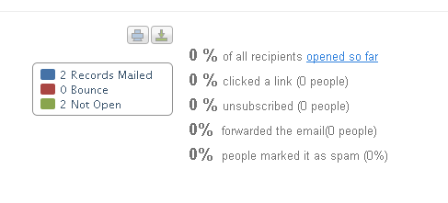

In reports displaying as mails not opened though it is opened in the mail.

Developer Comments:
Status: Open

Bug ID: #AD_017
Bug Type: UI/FUNTIONAL/NON FUNCTIONAL
Description: In the mail sent to the member from client site, in the footer Link10 Link & 10 are in separate lines. Should be same line.
Steps to reproduce: Go to Client site -> Try to create a new campaign-> In Campaign information page.
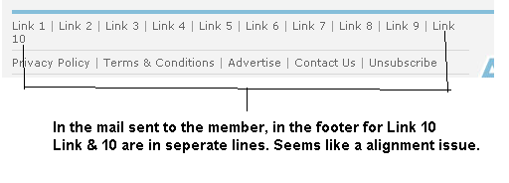
Developer Comments:
Status: Open

Bug ID: #AD_024
Bug Type: UI/FUNTIONAL/NON FUNCTIONAL
Description: When creating campaign in IE8, when we upload main image single is not working there but then double click is working fine.Where as in the same functionality works fine with firefox.
Steps to reproduce: From Admin Panel -> Try creating a campaign-> 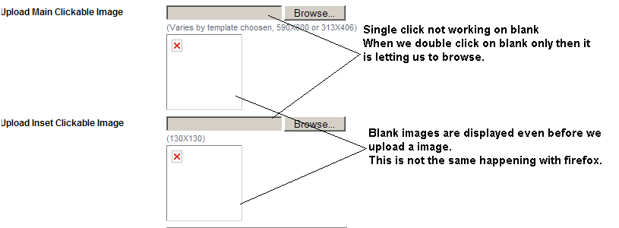
Developer Comments:
Status: Open:

